**Sheet 7**

Abishek Kumar

Ravikant Tyagi

Erce Can Balcioglu

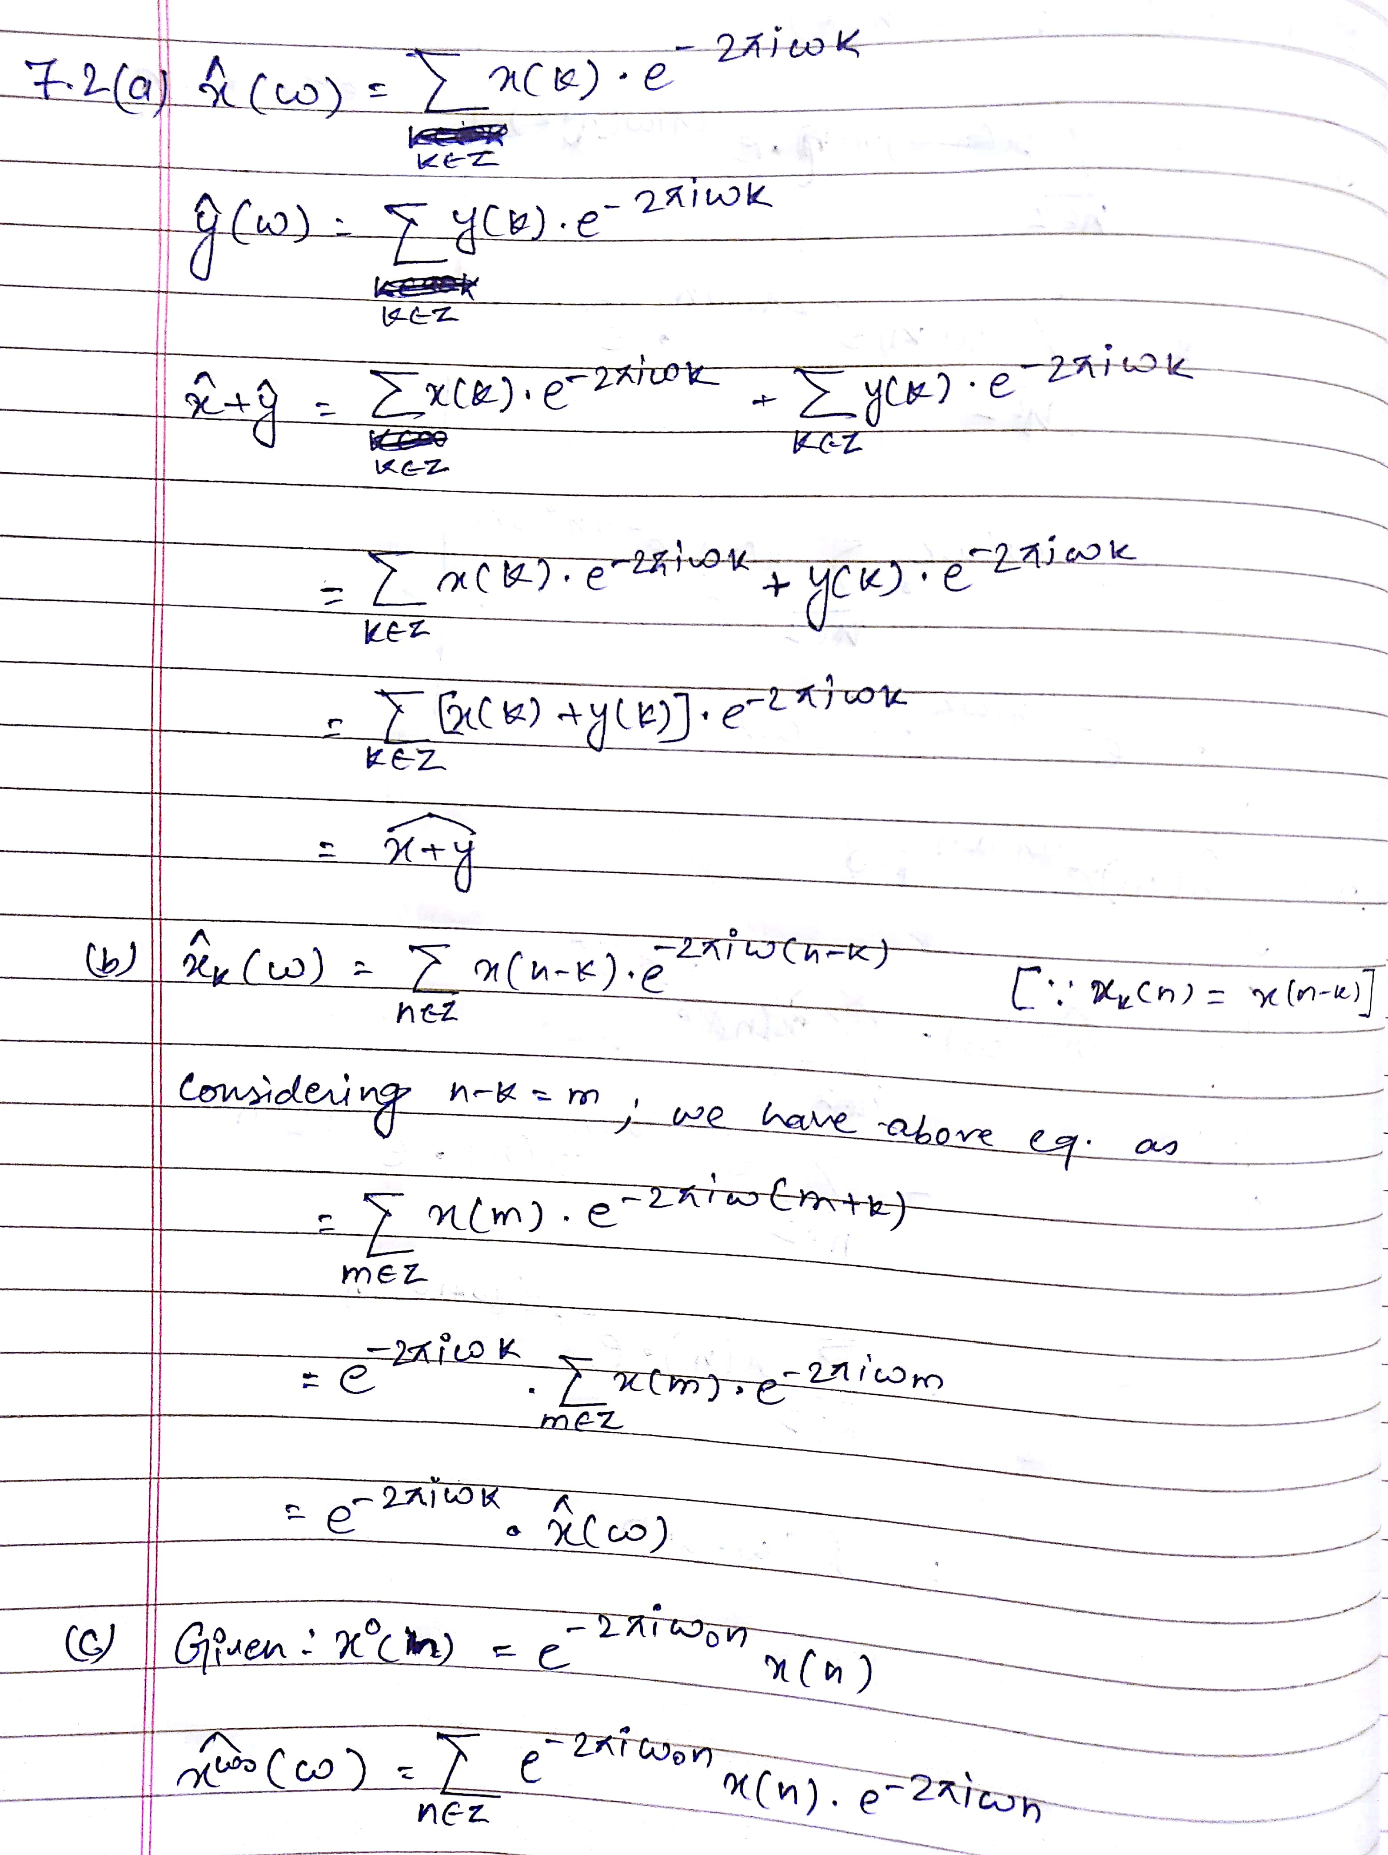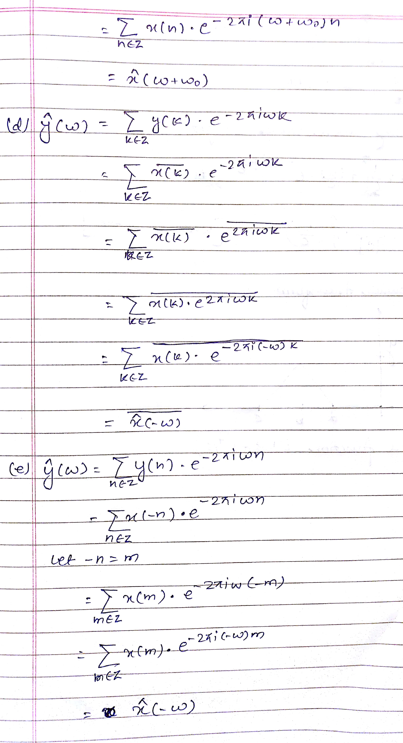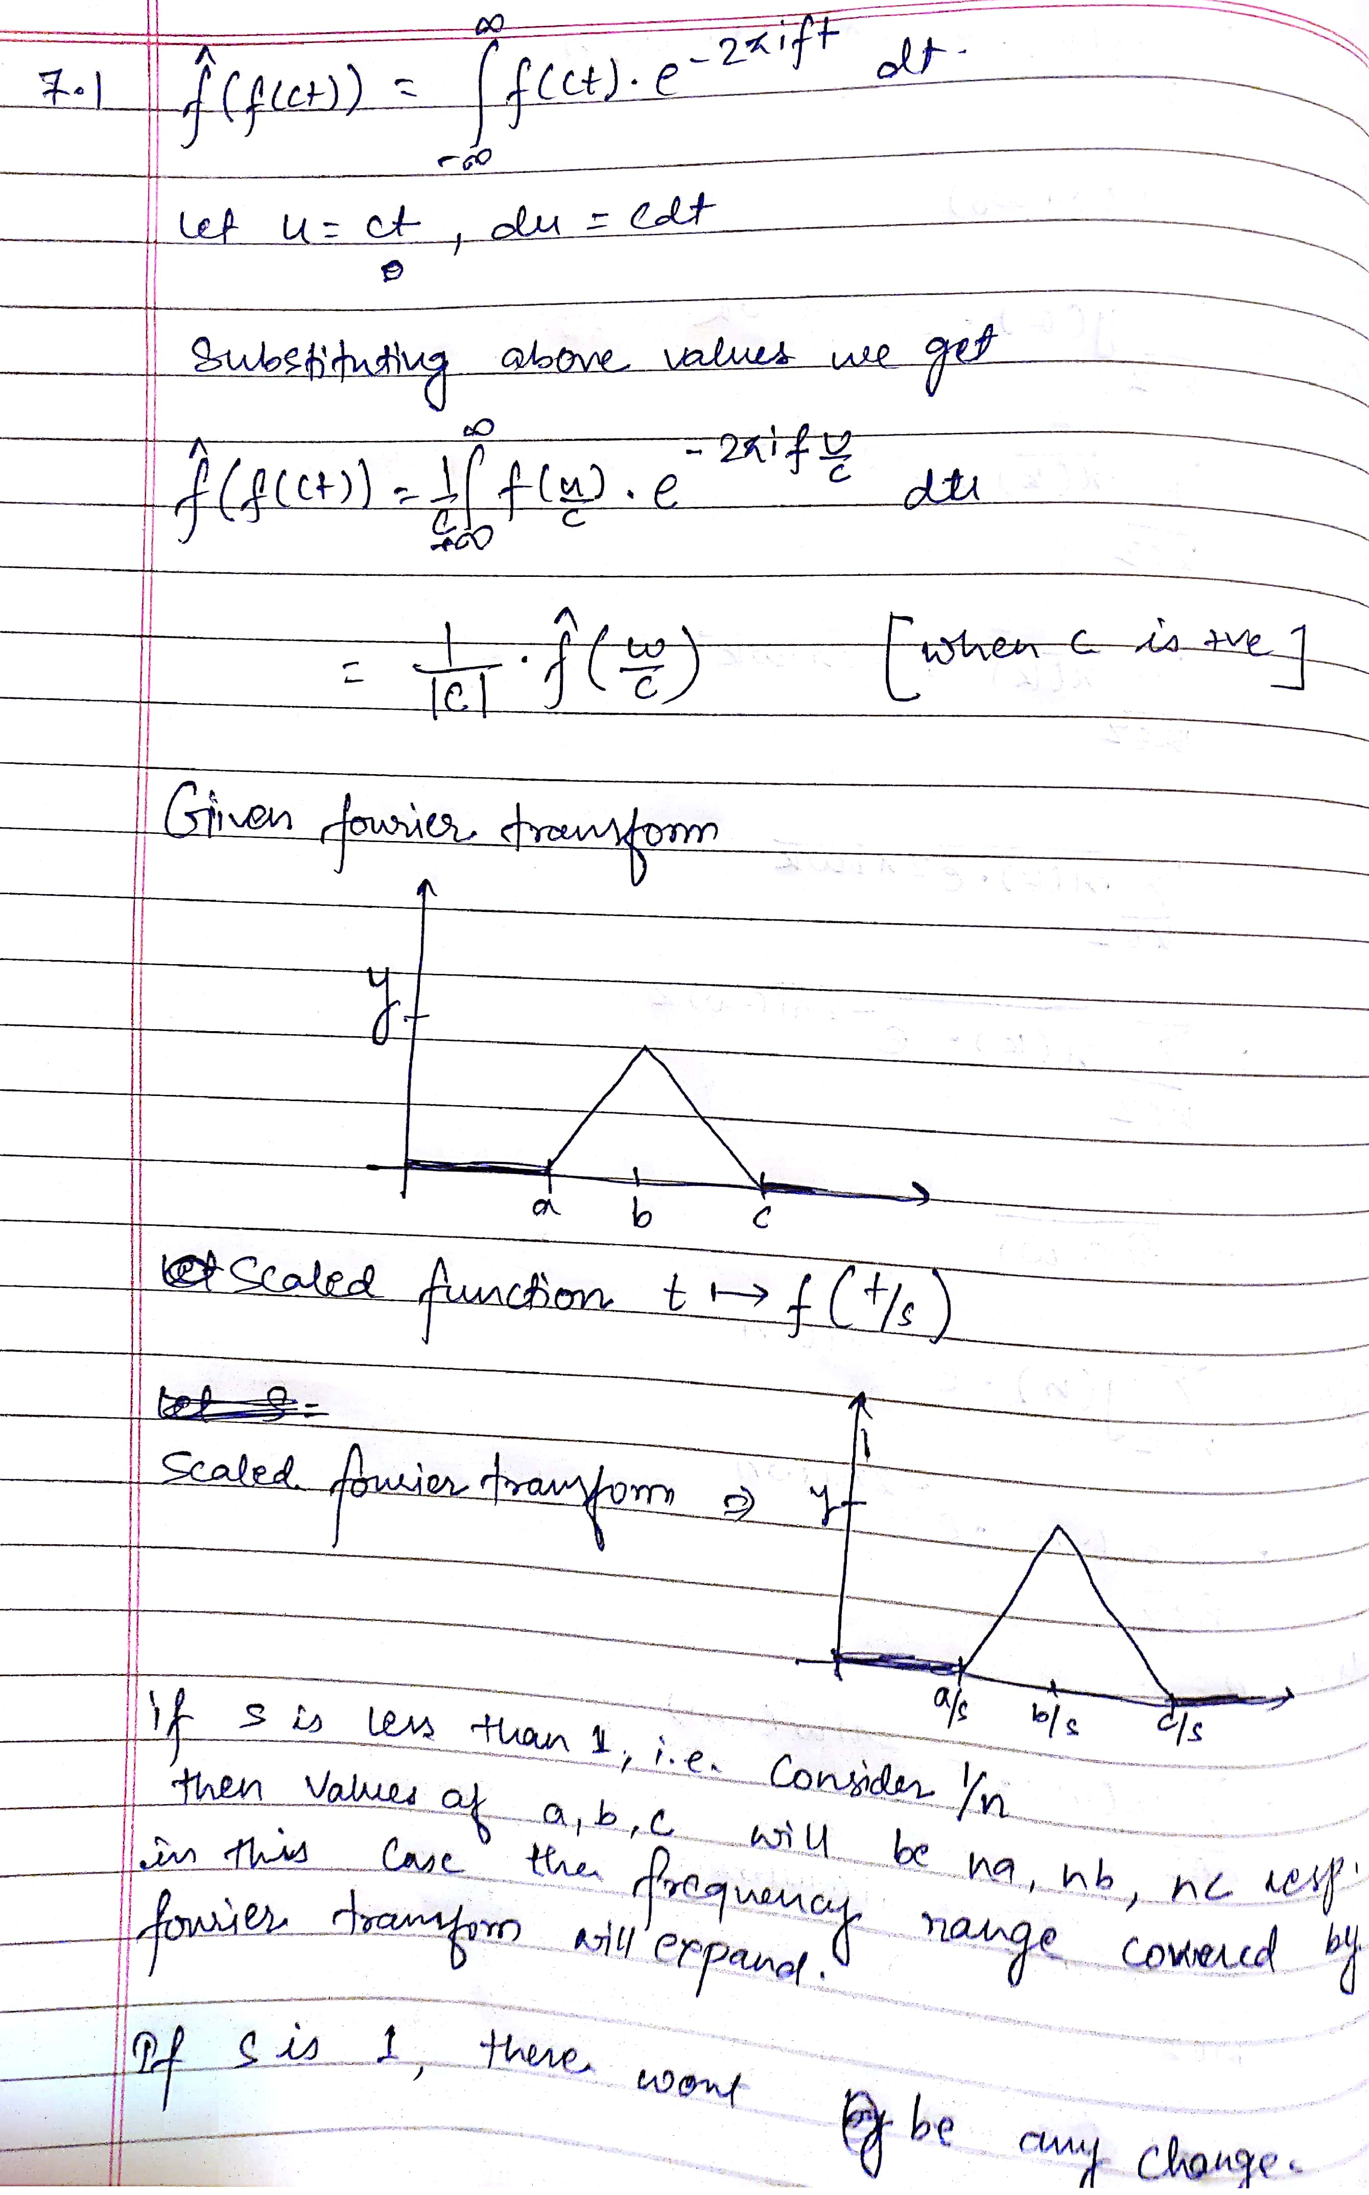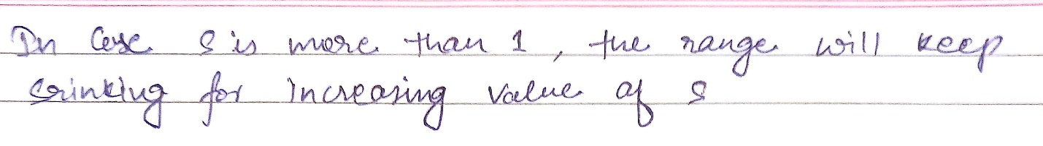

7.3

(a) Our approach is to find the total number of samples in the audio file and the sample rate. Using these two values we will find the total duration of the audio file.

Once we have samples and the duration of the audio file; we can get the samples corresponding to each time interval.

Once we have samples for each time interval, we will use the Fourier transform to find the frequency component contained with the samples. Once we have list of frequency content, using table we can find the dialed numbers.

(b)

Time Interval -> Dialed Number

0-1 -> 2

1-2 -> 5

2-3 -> 1

3-4 -> 2

4-5 -> 1

5-6 -> 6

